D. Y. Patil College of College of Engineering and Technology, Kolhapur
Department of Computer Science & Engineering

Class: SY-A Subject: AOOC
Experiment no: 15
Group No. G 16 Mini Project

Title of Mini-Project:
Quiz Making

Group Members:

Unique id | Roll No | Name of Student | Sign
EN23127382 | 58 | Diksha Santosh Nikam
EN23233299 | 59 | Rajanadini Shankar Musale
EN23218851 | 72 | Siddhi Balasaheb Patil
EN23267649 | 74 | Preeti Nishikant Sonule
EN23210759 | 75 | Tejal Navnath Powar

Problem Statement:
The goal of this project is to create a Quiz Making Application in Java that allows teachers to create quizzes and students to take them. The system will support adding questions, taking quizzes, and showing scores automatically. It helps make quiz-taking easier, faster, and more organized

Introduction:
Quizzes are a common method of testing knowledge in schools, colleges, and online learning platforms. Manually creating and checking quizzes can be time-consuming and inefficient. To solve this problem, we are developing a Quiz Making Application using Java. This application will allow teachers to create and manage quizzes, and students to take them and get instant results. It will make the quiz process faster, easier, and more accurate.

System Architecture:
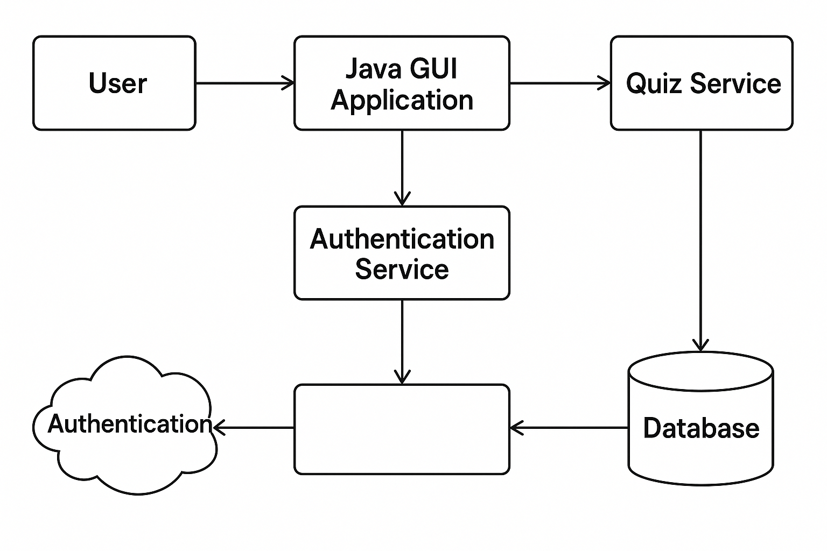
Module description or working of system:

1. User Interface (Java GUI - Swing/JavaFX)
- Displays quiz questions, options, score, login, etc.
- Allows users to select answers and submit them.
- Sends user input to the Quiz Controller.
2. Authentication Module
- Allows users to register or log in.
- Verifies credentials against stored user data.
- Grants or denies access to the quiz section.
3. Quiz Controller (Core Logic Layer)
- Loads quiz questions from the database or a file.
- Validates answers and calculates score.
- Handles quiz progression (e.g., next question, quiz end).
- Communicates between the GUI and the data layer.
4. Quiz Data Management
- Stores questions, options, correct answers, and scores.
- Can use:
  - Flat files (e.g., JSON, XML)
  - Local database (SQLite, MySQL)

🔄 System Working Flow
- User Launches App
  - GUI window opens with login/signup screen.
- Authentication Process
  - User enters credentials.
  - System verifies and grants access if valid.
- Start Quiz
  - Questions are loaded from the database or file.
  - One question at a time is shown in the GUI.
- Answer Submission
  - User selects an option and submits.
  - Answer is validated; score updated accordingly.
- End of Quiz
  - Final score is displayed.
  - Optionally, result is saved to database.

Screenshots:

